Dragon Armor

- Change History

0.4

- Updated 2.c.iv and 3.b.i to 3 piece naming structure.

0.3

- Removed Dragon Claws as a weapon
- Suffixes and Prefixes can now confer both % and absolute value bonuses

0.2

- Added BI logging section
- Added Great Dragon Claws as a weapon

0.1 Created Spec

- Overview

Allow players to equip the dragon with various pieces of armor. Armor may now be mixed/matched; each conferring statistical bonuses to the dragon. Items will allow provide new means for vanity and visual customization. Will allow players to socket each armor piece with gems to give empire-wide bonuses in the second phase of the feature.

- Business Objectives
  - Raise D60+ ARPU directly (through sales of premium dragon armor), and indirectly (through sales of speedups/combat buffs through marches against boss tiles)
  - Raise D30+ engagement and retention by allowing players to customize their dragon via armor, and by allowing players to farm NPC boss tiles for better loot.

- Specifications

- Outline

  - Players will be able to obtain various grades and types of Dragon armor within the game, which can be mixed and matched however the player wants
  - Each piece of armor will confer statistical bonuses to the dragon, based on a list item types and prefixes (below)
  - The statistical bonuses will ONLY affect the dragon wearing the armor. Other dragons controlled by the player will not be affected.
  - Dragon armor may ONLY be equipped once the dragon has matured (reached level 8)
    - The “Dragon Armory” modal will gate the player from equipping their dragon until the dragon reaches level 8
  - The dragon will receive stat bonuses from armor even if the player has yet to collect all four pieces of armor

- Dragon Armor

  - The following dragon stats may be affected by the armor:
    - Health
    - Melee Attack
    - Ranged Attack
    - Range
    - Defense
    - Speed
    - Load
  - For future releases, Dragon Armor may also confer additional bonuses, including, but not limited to the following:
    - Attack vs. [Unit Type]
    - Defense vs. [Unit Type]
    - Attack/Health/Range/Defense/Speed/ bonus of [Unit Type] marching with Dragon
  - Dragon Armor items have the following properties:
    - A name (string)
    - A unique Armor ID (each piece of armor is unique)
    - An item type
      - Great Dragon Armguards (armor)
      - Great Dragon Helmet (armor)
      - Great Dragon chest armor (armor)
      - Great Dragon Tailguard (armor)
      - (Other armor pieces may be added later)
    - A modifier Prefix (string)
      - May be empty
    - A modifier Suffix (string)
      - May be empty
    - An icon (determined by item type and quality rating)
    - A 3D model (determined by item type and quality rating)

- Dragon Armor Generation

  - Each item will only have ONE prefix and ONE suffix associated with it chosen from the dragon armor effect spreadsheet
    - Weights and odds are listed within the document
    - Both prefixes and suffixes have an associated quality rating (numerical), representative the relative rarity and strength of the item
      - Prefixes: E.g.: “Wood” : 1; “Copper” : 2; “Iron” : 3
      - Suffixes: E.g.: “Of Speed” : 1 ; “Of Quickness” : 2; “Of Alacrity” : 3
    - All prefixes bonuses can be represented in both absolute and percentage values
      - E.g., +1000 to attack OR +2% to attack
    - All suffix bonuses can be represented in both absolute and percentage values
      - E.g. +2% to attack, OR +1000 to attack
  - The name of the item is determined by a combination of a prefix, base item, and a suffix
    - For example, a Clawguard item with a quality rating of 5 (a Mythril Clawguard), the ‘Savage’ prefix and ‘the Heart’ suffix will have the name ‘Savage (prefix) Mythril Claws (base item) of the Heart (suffix)’
  - After a suffix has been chosen, randomize the bonus conferred from the “Bonus” column, with each 0.1% (percentage) or 1 (absolute) bonus having the same probability
    - A player receiving a claws with “the Brute” suffix (1-3% to the dragon’s melee attack) will have a 1/30 chance of obtaining a 1% buff, a 1/30 chance of obtaining a 1.1% buff, etc..
  - If an item receives an item whose prefix and suffix affect the same statistic, the absolute prefix modifiers are applied before the percentage bonuses
    - E.g., a Claw item with both a prefix of Melee/Ranged Attack + 1000 and a suffix of +3%
    - The item modifiers will be displayed as:
      - Attack: + 1000,
      - Attack + 3%
  - See below for item creation flow:

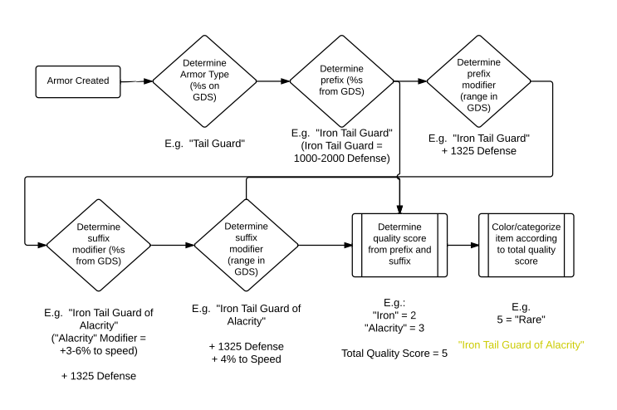

- Rarity

  - Rarities will be determined by a GDS based on the total quality score of the item
  - On the front end, the names for each items will be color coded according to rarity
    - White = normal
    - Blue = good
    - Yellow = great
    - Purple = awesome

- Acquiring Dragon Armor
  - Dragon Armor may be obtained by attacking NPC Boss tiles
    - See DropRates-GreatDragon for Drop Rates
  - If a piece of Dragon Armor drops from an NPC boss tile, there is a list of percentages that determines the quality of the item dropped

- Effect Stacking

  - Effects are stacked simultaneously. That is, if a user has 4 item that raise the dragon’s attack power by 5%, the dragon’s attack power will increase by 20%, not 5% of 5% of 5% of 5% of the dragon’s base attack

- Attacking with the Dragon
  - Dragons may now be sent on attacks as long as the following criterion have been fulfilled:
    - Dragon is level 8 or above
    - Aerial combat has been researched
      - Player must still recover all four pieces of dragon armor before researching Aerial Combat

- Paper Doll Dragon

- Different pieces of armor will have different appearances, which will be reflected on the Dragon’s 3D model, once equipped
- Once the dragon matures, equipping ANY piece of armor on the dragon will be reflected on the Dragon model
  - Players no longer need to equip the dragon with a full set of armor for it to be reflected on its character model
    - 2.b NOT FOR MVP. WILL BE PUSHED WHEN ADDITIONAL DRAGON ARMOR SETS ARE AVAILABLE

- Dragon Armory (Inventory)

  - The Dragon Armory is a modal used by players to manage/store unequipped pieces of Dragon Armor
  - Players will have a separate inventory for Dragon Armor. All Dragon Armor will now be stored within the Dragon Armory modal
  - Armor pieces obtained by the player will be stored in unlocked item slots in the player’s Dragon Armory
  - Transmuting Dragon Armor (Discarding Armor)
    - Players may choose to ‘Transmute’ armor in their Dragon Armory
    - Transmuting armor removes it from the Player’s Dragon Armory and adds gold to the player’s resources
    - Quantity of resources generated is based off “rarity” sheet in the Dragon GDS
    - Display Toaster alert after armor has been transmuted and removed
      - You have transmuted [Armor Name] into [X] Gold!

- BI and Logging

  - Once a piece of armor has been generated, the a BI event should be logged and created accordingly with the following parameters:
    - Category: ARMOR_CREATE
    - Parameters: date created, player ID, armor ID, origin (bought or from boss), type (helmet, tailguard, etc.), grade (wood, bronze, etc.), suffix
  - Once a piece of armor has been equipped on a dragon, the following BI event should be logged:
    - Category: ARMOR_EQUIP
    - Parameters: date created, date equipped, player ID, armor ID, equipped Dragon, equipped Dragon ID, origin (bought or from boss), type (helmet, tailguard, etc.), grade (wood, bronze, etc.), suffix
  - Once a piece of armor has been transmuted (discarded), the following BI event should be logged:
    - Category: ARMOR_DISCARD
    - Parameters: date discarded, value of discard, player ID, date created, armor ID, origin (bought or from boss), type (helmet, tailguard, etc.), grade (wood, bronze, etc.), suffix

- Admin Tools
      - The tool should allow the admin to perform the following actions:
- View and review the player’s dragons, including equipped dragon armor, stats, and any active buffs using player lookup.
  - Name of item
  - Quality of Base Item
  - Prefix
  - Suffix
  - Source ID
    - 0 = Given by admin
    - 1 = Purchased
    - 2 = NPC Instance Drop
    - 3 = Other
- View the number of locked/unlocked inventory slots by player
- The ability to remove dragon armor currently equipped on the player’s dragons
- The ability to remove dragon armor from the player’s inventory
- The ability to lock/unlock item slots
- The ability to create and gift dragon armor to the player’s inventory
  - Admin tool should prompt an error message if there are no inventory slots free

- Killswitches

There will need to be a few kill-switches in this feature, including

      - A Dragon Armor Item drop kill-switch
- When used, no dragon armor items will drop, but existing items may still be used

- UI

TBD

- Other Considerations
  - QA

- Marketing/community
  - None

- Localization
  - None

- Art Assets Needed

- Sounds Needed
  - TBD

- Legal Issues
  - None

- Customer Service
  - None

